Found PET
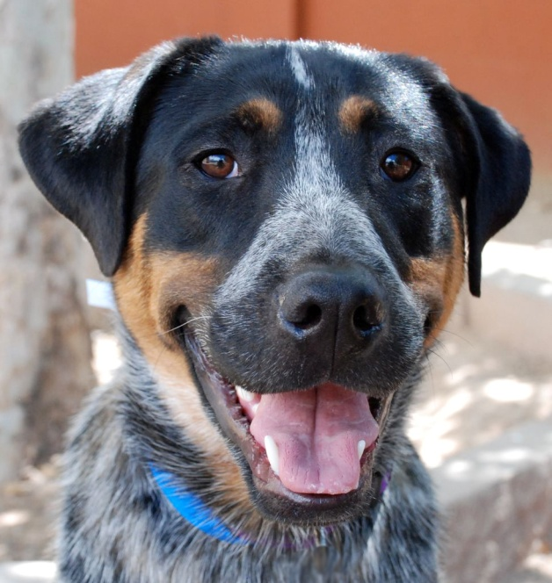
Pet Information

Pet Name: ex: Hugo Sex: Male

Breed: Cattle Dog Mix Color: Black, Brown, and Grey

Age: 3 years old Special Characteristic: 1 grey paw
Owner Information Last Seen at:
Name: Johhny Savesapet Telephone: 555-555-5555

Address: 1234 Humane St. Email: ilovemypets@yahoo.com

